**“AI-Based Smart Waste Bin Prediction System”**

**Introduction :**

As cities grow larger and more crowded, managing the waste they produce has become one of the most urgent challenges urban areas face today. With urbanization accelerating, the amount of waste generated daily is skyrocketing, and traditional waste management systems are struggling to keep up. Overflowing bins, missed garbage collections, inefficient truck routes, and poor waste sorting are all too common—leading not only to environmental issues but also to higher costs for local governments and a decline in public health and cleanliness.

The problem with conventional systems is that they often take a one-size-fits-all approach: bins are placed based on fixed schedules and outdated assumptions, not on actual needs. This results in wasted resources—some areas end up with too many bins, while others don’t have nearly enough. Plus, these systems can’t easily adjust to changes in population, business activity, or seasonal waste trends.

To tackle these issues, this project introduces an AI-powered Smart Waste Management System. By combining artificial intelligence with data analytics, the system aims to optimize how bins are placed and how often they’re emptied—making waste collection smarter, faster, and more efficient. It analyses patterns in historical data such as bin fill levels, collection frequency, population density, and commercial activity to predict where and when waste will build up. Based on these insights, city planners can make better decisions about the number, type, and location of bins in different neighbourhoods.

The ultimate goal is to shift from a reactive approach—where action is only taken once a problem arises—to a proactive and predictive one. AI techniques like regression analysis, clustering, and classification help identify trends in waste generation and provide valuable recommendations. When combined with IoT-enabled sensors that monitor bin levels in real-time, the system can even optimize garbage truck routes on the fly. This not only speeds up waste collection and cuts fuel costs but also reduces emissions and supports sustainability efforts.

In short, this AI-driven solution offers a smarter way to manage urban waste. By using modern technology to guide decisions, cities can become cleaner, greener, and more efficient—moving a step closer to the vision of smart, sustainable urban living.

**Problem Definition:**

**Problem Statement:**

* Cities are struggling with outdated and inefficient waste management systems.
* Overflowing bins are common due to too few bins or delayed collection, leading to unhygienic conditions and health risks.
* Waste segregation is poor because bin types are not matched properly to the type of waste generated.
* Collection routes and schedules are static and don’t reflect actual waste patterns, causing unnecessary fuel use and higher operational costs.
* Municipalities lack intelligent tools to forecast needs and optimize bin distribution or collection timing.

**Background Information :**

* Some smart systems use IoT sensors to monitor bin levels in real time.
* However, very few use AI or machine learning to predict future waste patterns.
* AI can help analyse past data and environmental factors to suggest where bins are needed, and what type.
* A web-based dashboard can give city officials easy access to insights, helping them make faster, smarter decisions.

**Objectives:**

**Primary Objectives:**

The primary aim of this project is to develop an AI-powered Smart Waste Management system that improves the efficiency, sustainability, and hygiene of urban environments. The core objectives are:

* Predict the required number of bins per street using machine learning regression models trained on historical data, including bin fill levels, population density, and collection frequency. This allows for dynamic allocation based on real need rather than fixed assumptions.
* Classify the type of bins needed in different regions (e.g., organic, plastic, metal) using classification algorithms. This ensures proper waste segregation and supports effective recycling and composting strategies.
* Determine optimal bin placements by applying geospatial clustering algorithms and generating heatmaps. This helps identify high-density waste zones and deploy resources efficiently.
* Visualize predictions and insights through an interactive web dashboard, enabling municipal authorities to track, analyse, and plan waste management operations in real time.
* Optimize collection schedules by analysing historical and predicted fill rates, ensuring trucks are dispatched only when necessary, reducing fuel costs and carbon emissions.

**Secondary Objectives:**

* Enable real-time monitoring through future integration of IoT sensors for live bin status and fill-level tracking.
* Provide a scalable framework that can be extended to other urban services such as water management, air quality monitoring, and traffic flow optimization.

**Methodology :**

**Approach:**

The project adopts a machine learning-based predictive approach:

* Regression models forecast bin counts and fill times.
* Classification models detect waste types dominant in different zones.
* Clustering techniques (e.g., K-Means) assist in identifying optimal bin locations.
* Data visualization tools display results on a dynamic map-based dashboard.

**Procedures:**

* Data Collection: Gathered data on bin ID, geolocation, fill rates, and waste types.
* Data Preprocessing: Cleaned and structured using Pandas in Python.
* Model Training: Trained using scikit-learn for regression and classification.
* Prediction Output: Exported results as JSON.
* Frontend: Developed using HTML, CSS, and JavaScript to display maps and graphs.

**Tools and Techniques Used :**

**Tools:**

* **Languages**:
  + **Python**: Core language used for data analysis, machine learning model development, and backend logic.
  + **HTML, CSS, JavaScript**: Used to build and style the interactive web dashboard for visualizing data and predictions.
* **Libraries**:
  + **Pandas**: For data manipulation and preprocessing of historical waste data.
  + **NumPy**: For numerical operations and matrix-based computations.
  + **Scikit-learn**: Used for implementing machine learning models such as regression and classification algorithms.
  + **Matplotlib**: For generating visualizations like charts and trend graphs.
  + **FPDF**: For creating downloadable PDF reports summarizing predictions and analytics.
* **Technologies**:
  + **JSON-based Web Dashboard**: A lightweight, structured data-interchange format is used to feed real-time and processed data into the dashboard, enabling dynamic content updates without refreshing the entire page.
  + **Machine Learning Models**: Core to the system's intelligence, ML models are trained to learn from historical data and make accurate predictions about bin needs and placements.

**Techniques:**

* **Regression Analysis**: Applied to forecast the number of bins required per street and estimate the average time it takes for bins to fill. This helps optimize bin distribution and collection frequency.
* **Classification**: Used to determine the most common waste type (e.g., organic, recyclable, or hazardous) in specific areas, enabling appropriate bin-type allocation.
* **Geospatial Clustering**: Techniques such as K-Means or DBSCAN are employed to group geographical coordinates based on waste generation patterns, helping identify ideal locations for new bins or reallocation.
* **Visualization**: Interactive charts, heatmaps, and graphical representations are used to communicate complex analytical outcomes clearly to decision-makers via the web dashboard.

**Proposed Results:**

This project aims to deliver significant improvements in urban waste management through the application of AI and data analytics. The expected outcomes include:

* **Accurate Prediction of Dustbin Numbers and Types (85–90%)**:  
  By training machine learning models on historical waste generation data and location-specific attributes, the system can accurately predict the optimal number and type of dustbins (organic, recyclable, general waste, etc.) required per street. Achieving a prediction accuracy of 85–90% ensures high reliability in bin allocation and better resource utilization.
* **Geospatial Visualization of Optimal Placements**:  
  Using geospatial clustering techniques and heatmap visualizations, the system will identify high-waste-density zones and suggest optimal locations for placing bins. This helps municipal planners visualize demand areas spatially and make informed, data-backed decisions for bin placement.
* **Improved Collection Scheduling**:  
  Incorporating real-time or historical bin fill-level estimation allows for smarter scheduling of collection trucks. Instead of using fixed routes, trucks can be dispatched only when necessary, reducing unnecessary trips, fuel consumption, and operational costs.
* **Reduction in Overflow Incidents and Enhanced Segregation**:  
  By ensuring that the right type and number of bins are available in the right locations, the project will help reduce bin overflow and promote proper waste segregation. This not only improves public hygiene and urban aesthetics but also increases the effectiveness of downstream recycling and processing.

**Roadmap:**

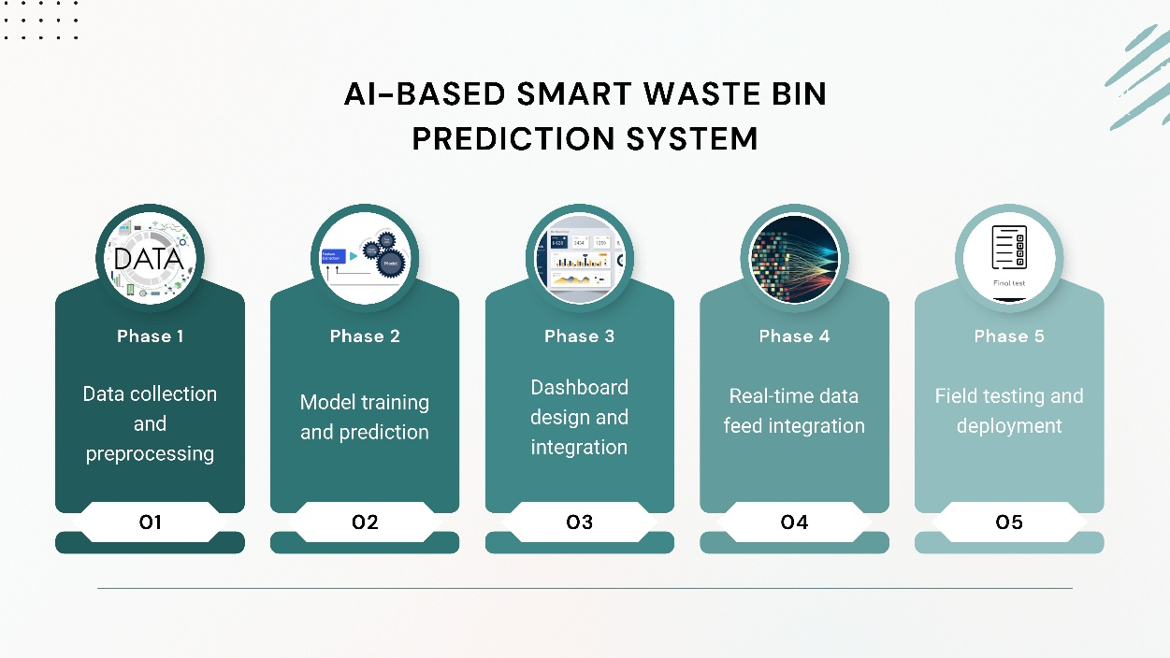

**Literature Survey :**

1. Artificial Intelligence for Waste Management in Smart Cities (2023)  
   A review of AI technologies applied in urban waste classification, routing, and recycling.
2. Sustainable Waste Management with AI (2023)  
   Combines deep learning and IoT for waste classification and methane monitoring.
3. Advancements in Waste Segregation Through Machine Learning (2023)  
   Discusses AI-driven methods to improve automated waste segregation efficiency.
4. Ingenious Waste Management Using Machine Learning (2023)  
   Focuses on ML techniques for classifying and managing different waste types.
5. Predictive Waste Management with Particle Swarm Optimization (2023)  
   Uses AI and optimization algorithms to forecast waste patterns and improve planning.
6. Automated Waste Sorting with Vision-Based Transformers (2024)  
   Introduces a transformer model for automated image-based waste classification.
7. GIS-Based Urban Waste Collection Route Optimization (2019)  
   Applies geospatial analysis to improve waste collection efficiency in cities.
8. 3D Urban Design and Procedural Modeling (2020)  
   Enhances urban planning through data visualization using 3D modeling tools.
9. Interactive Dashboards for Smart City Management (2021)  
   Case study on real-time dashboards to monitor and manage smart city infrastructure.
10. IoT for Smart Waste Management (2019)  
    Explores IoT integration in urban waste systems for real-time monitoring and routing.